Essex County Council | 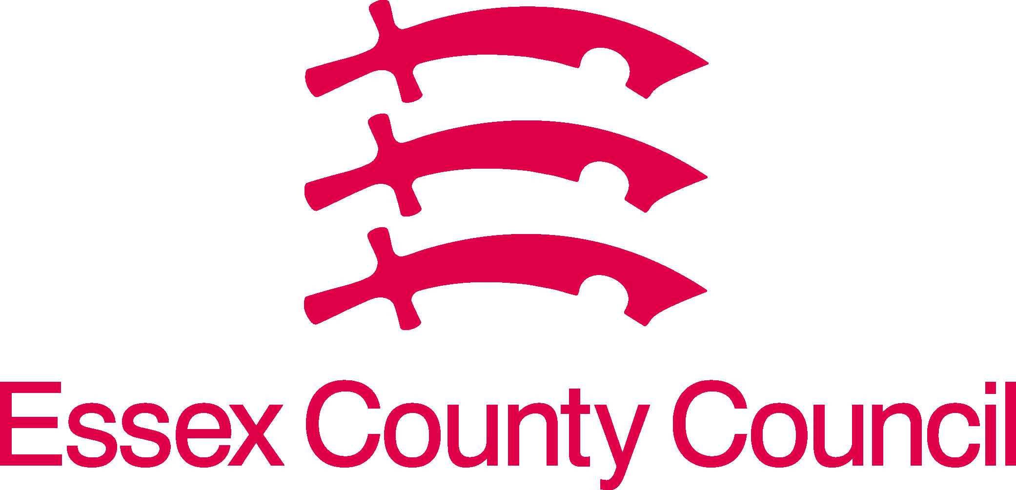
Leader’s Office
PO Box 11, County Hall
Chelmsford
Essex CM1 1LX

Date: 11 November 2020

To: Covid-19 Essex business roundtable members

Dear colleagues,

Thank you for another productive meeting last Thursday and for taking the time again to speak to me and my fellow council leaders in Essex.

We have found it invaluable to hear your views and concerns directly. Essex County Council and your local district councils remain committed to supporting you in the weeks and months ahead, protecting people’s jobs as well as ensuring we save lives as we all battle to control the virus.

It is our clear aim that Essex should exit the national measures in early December into the lowest coronavirus alert level (called medium level or tier 1). This should be possible if there is a high level of compliance across Essex this month, given the effect of our early action in entering the Higher level (tier 2) on 17 October to flatten the curve. We hope to see the effect of that early action start to come through in the data shortly, and set us on the right trajectory for being among the first areas to come out of the national measures. This would enable Essex businesses to re-start trading for the crucial Christmas period.

I wanted to write summarising the other key issues we have heard from you and what we are doing in response. Of course, we will need to remain flexible as the circumstances evolve, and I welcome your ongoing input into our plans.

- Lobbying central government
Following the move into Higher Level (tier 2), we lobbied central government for financial support for businesses, which was then announced. The grants announced by Government for businesses in tier 2 will still be made available, backdated for the period that Essex was in tier 2 before the new national measures were implemented. A number of national measures were also introduced with the extension of the job retention scheme and allowing businesses to top up bounce back loans.

- Additional financial support to help businesses adapt to the tier 2 restrictions
We proposed that half of the £4.4m that Essex was receiving from central Government would support businesses (with the rest going to vulnerable residents and communities). We announced on 30 October that that £2.2m pot would be used to provide a Business Adaptation Grant of £1,500, focused on the hospitality industry. In the light of the new national restrictions meaning the hospitality industry will be largely close this month, and with additional funding being made available (£20 per head which should be circa £28m to Essex), we are re-evaluating this grant. A further update is below.
- Clear information and advice
Given the fast-moving circumstances and often complex rules, you asked for clear information particularly for the hospitality industry, to clarify the rules and set out sources of support. The latest version of our factsheet is attached. Our website contains the most up-to-date advice and support: www.essex.gov.uk/topic/coronavirus. Feedback on the factsheet and website is very welcome.

- Business Advice on adaptations and support
Up to 12 hours’ free advice is available from ‘Back to Business Essex’ delivered by the Let’s Do Business Group, fully funded by Essex County Council. https://www.backtobusinessessex.co.uk/ ,

‘Business Essex Southend & Thurrock (BEST) Growth Hub’ can help you identify programmes, initiatives and funding you can access. https://southeastbusiness.org.uk/essex-southend-thurrock/

- Streamlined process for additional outdoor space
We have streamlined the application process for businesses wishing to use pavements or road space for outdoor seating. To find out more and apply please see the accompanying factsheet. Or email Covid19BizSupport@essex.gov.uk.

- Employee Wellbeing Support
The Essex Wellbeing Service can help private sector organisations look after their employees’ health and wellbeing: https://www.essexwellbeingservice.co.uk/

- Boosting consumer confidence
Visit Essex launched a new marketing campaign Great Days Out, Close to Home with mini campaigns to support the hospitality, retail and tourist industries. These are now paused due to national restrictions but will be re-started when they are lifted.

- Preparing for a strong re-opening in December and next year
While recognising that – despite the current Government support - these weeks will be devasting for many businesses, we want those businesses that can re-open in December to have a strong pre-Christmas trading period. We will also need to develop plans for the first quarter of 2021. Essex County Council and the district councils are therefore working on:
- further lobbying the Government on issues that you have flagged to us, including further business adaptation (e.g. many micro and small businesses haven’t had websites and online payment arrangements before), and the removal of the job retention bonus;
- boosting consumer confidence by re-starting and expanding our marketing campaign Great Days Out Close to Home;
- discussing with Business Improvement Districts and other local groups how we can support our town centres and high streets.

- Further financial support following introduction of national restrictions
Government has announced that funds will be distributed on the basis of £20 per head, our estimate is this is £28m for Essex. We understand this will be sent to district councils to administer and is funding for 20/21 and 21/22. The County and the district councils across Essex are working to determine how best to use this funding, in addition to the £2.2m we had already allocated for business support. At last Thursday’s session we heard the following feedback:

Areas of focus should be:
- Hardship – support the businesses that have suffered the most from restrictions
- Investment is needed to ensure 3rd December reopening is as successful as possible
- Focus on building consumer confidence, positive messages but reassurance on safety
- Investment should also be considered for longer-term adaptations that will help business grow on recovery – click & collect, online presence

How:
- Speed in getting funding to business is critical – cashflow is main concern for many businesses
- Targeted – ensure funding goes to the businesses that have been most impacted, not all have.
- Consistent – businesses will operate in multiple places and want consistency in how schemes operate
- Simple – easy to apply for.

We await the funding from Government which will come with specific terms and conditions. As soon as we have this, we will provide a further update and arranged further meetings to discuss. We will also want to consider what support is needed for individuals who have, or will, lose their jobs.

I very much look forward to continuing our discussions at a further roundtable in the near future. In the meantime, both Councillor Tony Ball (the Cabinet Member for Economic Development) and I will also be meeting a range of businesses across Essex over the coming weeks. Our team would welcome your comments and ideas on all the above, please get in touch at: Covid19BizSupport@essex.gov.uk.

Please share this letter and factsheet with your fellow businesses. I am grateful to the Essex Chambers of Commerce, Federation of Small Businesses, Confederation of British Industry, and the Institute of Directors, for also cascading it to their members in Essex.

Thank you for everything you have done over the past months to tackle the coronavirus and protect people’s lives. These are extraordinarily difficult times but by working together we will control the spread of the virus and get back to normality as soon as possible.

Yours sincerely

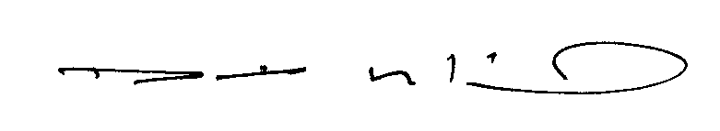

Cllr David Finch
Leader, Essex County Council

Excluding Southend and Thurrock

